SCENE SETTER
Visit to Communal Mayors’ Assembly 48 Cantones of Totonicapán

Purpose: To sign present the Funding Agreement being awarded for, as well as to present the background, basic structure and functions of the Communal Mayors’ Assembly the 48 Cantones of Totonicapán.

Background:
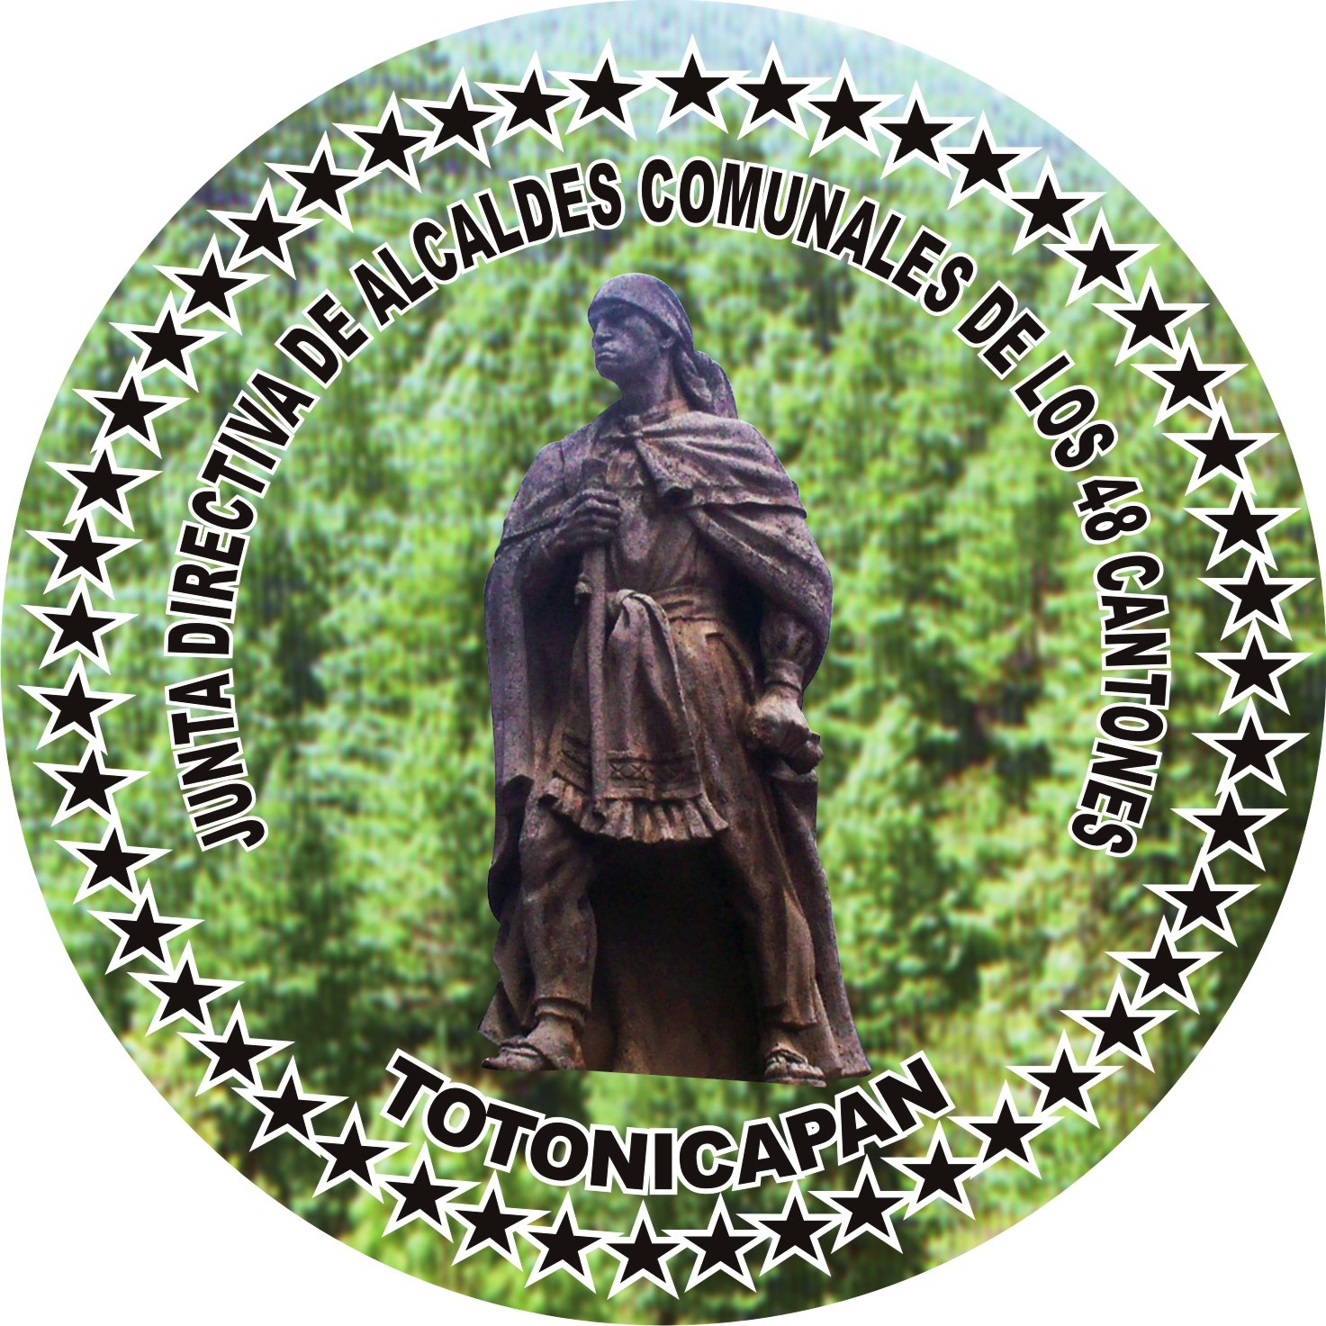
The Communal Mayors’ Assembly of the municipality of Totonicapán, called Los 48 Cantones de Totonicapán, is a powerful community structure in which has been manifested the will of the town of Totonicapán and its 44 sub-communities, for many generations. The 48 Cantones of Totonicapán is a diversified conglomerate of five distinct assemblies and their respective Boards of Directors (Junta Directivas), that are charged not only with protecting the communal natural resources, but also must respond to problems, threats and delinquency in all of the distinct communities (cantons) in the municipality of Totonicapán, administer and provide maintenance for common goods and services, and preserve traditions and historical documents of the pueblo.

Serving as a member/delegate of an Assembly or a Board of Directors of the 48 Cantones of Totonicapán is an obligatory year-long service, to be completed no more than three times in the lifetime of a citizen. This year of service is known as the k’axk’ol in k’iche’, meaning “suffering”, implying that it is not an option nor is it an election; those given the honor of being selected to serve for a year do not campaign for positions, and do not receive any economic or other benefits by completing their year of service. It usually implies an economic burden (and often other forms of hardship), and for that reason is not taken lightly by those serving nor by the communities served.
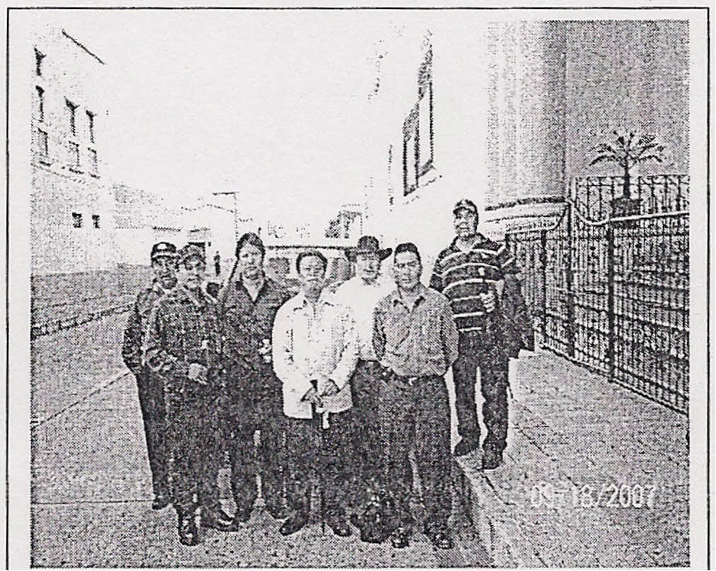
The 48 Cantones of Totonicapán has 5 Assemblies, or major bodies, to each of which a member from each of the 48 Cantones is selected every November. These assemblies are listed here along with their primary (understood) functions. From each assembly a Junta Directiva is elected:
- Baños. Charged with the cleaning, upkeep, and any infrastructure or maintenance problems with the Baños de Agua Caliente, the major hot-spring baths located on the southern side of the urban center, bordering Zona 3.
Junta Directiva of Alcaldes, 2006
- Alguaciles, primera quincena and
- Alguaciles, segunda quincena. In charge of patrolling the Casa Comunal in 24-hour shifts, and protecting the historical documents of the town. The two separate assemblies exist to take turns every two-week period.
- Recursos Naturales. Somewhat recently formed (2008), charged with the technical and labor aspects of 48 Cantones’ principal objective, protecting the 21,000 hectare Communal Forest. This implies reforesting and production of saplings in the nursery, several patrolling rounds per year (especially near Christmastime when illegal extraction of the protected Pinabete species is at its highest), settling land ownership disputes, settling spring ownership disputes, catching offenders illegally chopping down trees, etc.
- Alcaldes Comunales. Usually consists of alcalde comunal and vice-alcalde comunal from every community, resulting in a body of 96 members. Involved in disputes, resolving cases of delinquency or other small crime, participating in events in their communities to make decisions, etc. All incoming and outgoing assemblies participate in the selection of this Junta Directiva, because in this Junta (and especially in its president) is manifested the authority and legal representation of the 48 Cantones.

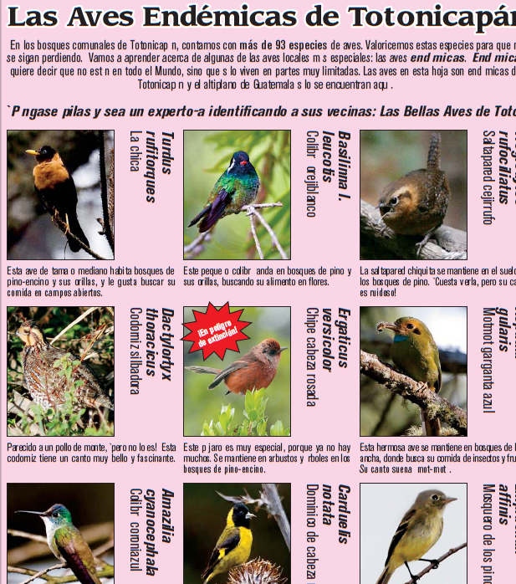
The major contribution the 48 Cantones de Totonicapán makes to the rest of Guatemala and indeed, the rest of the world, is its preservation of the Communal Forest. Totonicapán is the most densely populated department in Guatemala excluding the capital city, and one of the most impoverished departments. It is also, incongruently, the department with the highest percentage of forest cover. These self-contradicting facts belie Totonicapán’s incredible capacity as a community to protect their natural resources, but also indicate that there are incredible risks to and pressures on the forest. The Communal Forest of Totonicapán represents the largest and most well-preserved coniferous forest in all of Central America and has been communally managed and conserved to the present-day without much outside influence nor interference. The forest houses over 1,200 springs which are the headwaters for five of Guatemala’s major rivers (Samalá, Chixoy, Nahualate, Motagua, and Quiscab which drains into Lake Atitlan), and which are the only source of water through the six months of dry season, in mountainous country where rainwater from the wet season is quickly swept down and away. As we know, the content of the aquifers is directly related to the extent and quality of forest cover in these mountains. Naturally, the Communal Forest is also where one finds countless sites sacred to the Maya K’iche’ people, and Mayan ceremonies are performed quite frequently. From a scientific standpoint, the Communal Forest of Totonicapán contains, in spite of its climatic conditions, a stunning biodiversity of both plants and animals including over 100 species of birds around 30 of which are endemic to the highland coniferous forests of Guatemala and Mexico. Also at home here is the endemic and endangered Guatemalan fir, the previously-mentioned Pinabete. With changing global temperatures and local climate change (especially rains increasing in duration, frequency, and intensity) , forest cover is likely what has saved Totonicapán and its communities from major landslides, droughts, and other climatic catastrophes.
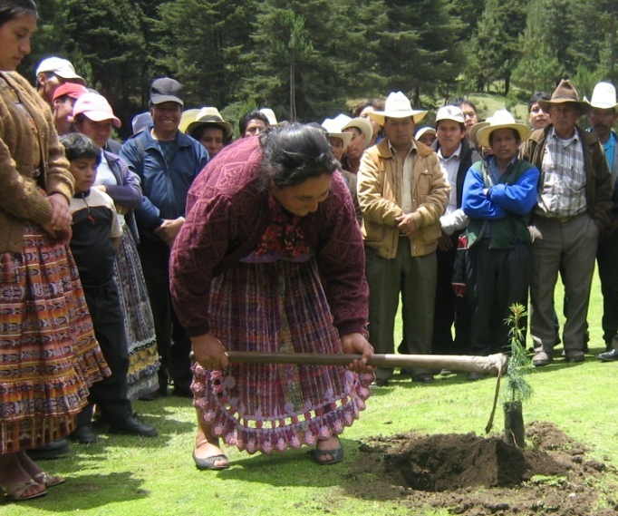
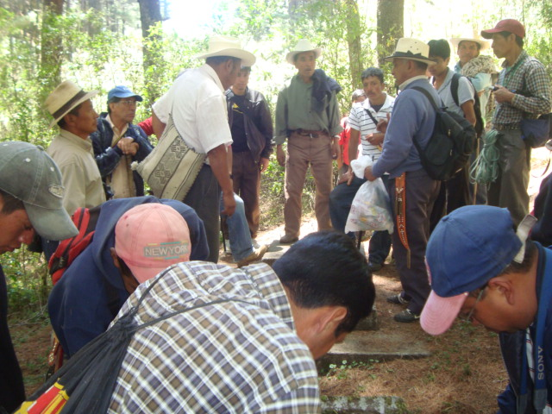
Since Totonicapán’s population continues to grow, and pressures on the Communal Forests’ resources with it, it is ever-more indispensable that measures be taken to aid the 48 Cantones in their efforts to conserve their forests, taking traditional methods like community standards for reforestation campaigns, along with trying out innovative new methods like market-driven payments for environmental services. The Junta Directiva de Recursos Naturales has taken initiative to seek external help with reforestation and tree nursery supplies and costs, as well as with community environmental education or training regarding good environmental stewardship. And a need has also been perceived to improve income alternatives in Totonicapán based on the communal forest, being that every day more and more individuals turn to illegal wood extraction as their primary source of income. Some ideas have already been proposed and rejected (nature-based tourism is one of those ideas that has never gained support in Totonicapán, for cultural reasons and due to the difficulty of ensuring that the economic benefits would be distributed and used to further 48 Cantones’ objectives); some alternatives have yet to be truly tested on a grand scale (non-timber forest products, for instance).

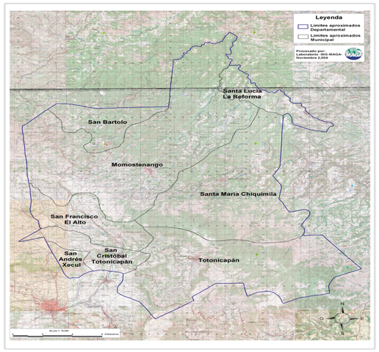
One major strength of the 48 Cantones of Totonicapán, which has in certain situations proven to be a weakness, is its lack of financial capabilities. 48 Cantones does not have the legal capacity to manage funds (personería jurídica), a fact that elevates this community structure above vulnerability to financial corruption and embezzlement. In its past, 48 Cantones has had negative experiences with community groups, NGOs and governmental organizations, taking advantage of the communal resources for their own gain (the creation and legalization of association Ulew Che Ja, formed to take on the forestry component covered now by today’s Recursos Naturales, is one example; various funding grants were handled by this association, but in the end it was subject to corruption, a great deal of money was embezzled, and the 48 Cantones was left to deal with the damage when the association dissolved as a result). This kind of negative experience gives rise to the current reality: the legitimacy of 48 Cantones, in the eyes of the community, lies in the fact that it is totally outside the governmental, legal, and financial framework. This aspect allows the 48 Cantones model to be kept in check by the community members, who are collectively and constantly performing a watchdog function. The 48 Cantones model is essentially, therefore, outside the legal framework of Guatemala, because it existed long before that legal framework did.

Main participants:

- Embassor Mr. Stephen McFarland
- Nancy L. Hoffman
- Rick Garland
- Teresa Robles
- Leticia Teleguario
- Romeo Tiu

Other guests:

- Hellen Mack

Proposed Agenda:

AGENDA

Memorandum of Understanding Signing Ceremony with
Community Mayors from 48 Cantones

Totonicapán, Indigenous Municipality Office

Saturday, March 26th, 2011
06:00 am – 17:30 pm

6:00 Leave from Official Residence
9:00 Arrive Totonicapán
9:05 Opening of 48 Cantones Assembly Meeting
9:15 Community related items to be resolved by Community board (Chairman Lic. Romeo Tiu is considering the participation of Mr. Stephen McFarland to understand how the community level works)
10:15 Helen Mack´s participation and dissertation as part of the security agenda of 48 Cantones

11:15 MOU Ceremony (Chairman Romeo Tiu and the Board will start as part of the meeting)
11:25 Presentation and Summary of activities by Alejandro Santos, Rainforest Alliance National Coordinator
11:40 Remarks from Mr. Stephen McFarland, Ambassador United States of America
11:55 MOU Signing Ceremony: Board Representatives from the 48 Cantones, Rainforest Alliance and Mr. Stephen McFarland.
12:05 Remarks from Mr. Romeo Tiu, Chairman of Indigenous Mayors.
12:25 – 13:40 Lunch with the 48 Indigenous Mayors, Rainforest Alliance, Ecologic and other invitees from the community (TBD).
13:55 Leave Totonicapán
17:30 Arrive in Guatemala City

Participants:

US Embassy:
- Ambassador Stephen McFarland
- Mrs. Karin McFarland (TBD)

USAID
- Rick Garland
- Teresa Robles
- Leticia Teleguario

Peace Corps
- Molly Roske

Rainforest Alliance
- José Román Carrera
- Alejandro Santos

Totonicapan:
- Indigenous Chairman and Board of Director’s Secretary: Lic. Romeo Tiu
- Municipal Mayor from Totonicapán: Miguel Bernardo Chavaloc Tacam (TBD)
- Governor of Totonicapán: Mr. Augusto Tzunun Talé (TBD)

Event Officer: Teresa Robles, USAID
Tel: 2422-4000
Cel: 5208-9569

Totonicapán
      - Romeo Tiu, President
Cellular: 5991-9357

      - Alejandro Santos, RA
Cellular No. 5825-4068

Attire: Formal Dress

Suggestions for the visit:

- Comfortable clothing and shoes
- Purified water

Event officer:

Coordination and Logistics:

